**What was already known about the topic concerned:**

**Social Distancing, Curfews, and the Domestic Economy**

Meanwhile, enforcing the necessary social distancing measures, and subsequently, curfews have effectively stalled the local economy. Whilst some economic activities that can be carried out remotely continue, particularly in the services sector, manufacturing and retail services have effectively come to a standstill. Moreover, even though the government has allowed agricultural production to continue unhindered, uncertainties surrounding temporary lifting of curfew hours and means of distributing essential goods to households result in wastage and a slowdown in the supply and storage of perishable agricultural goods.

Whilst many will feel the economic hardships, the exact short-term impact is difficult to estimate just yet. Daily wage earners and MSMEs, including those in the informal sector, are going to be disproportionately affected during the current crisis. MSMEs account for [52% of total GDP and 45% of national employment.](http://www.industry.gov.lk/web/images/pdf/framew_eng.pdf) Meanwhile, [nearly a half](http://www.statistics.gov.lk/Pocket%20Book/chap03.pdf) of the population is employed in the non-agricultural informal sector. Therefore, the absence of any meaningful economic activity for an entire month, and possibly longer, will severely affect the wellbeing of those involved. Since many MSMEs operate on thin margins and low levels of reserve savings, a prolonged lockdown without adequate support would lead to unemployment and foreclosures, with few surviving until the resumption of economic activities.

# Coronavirus outbreak predicted to have an impact on financial markets and the global economy

According to an Ipsos online survey conducted between February 14 and 15th in nine large countries, Japan is the mostly likely to agree that the coronavirus outbreak will have an impact on the financial markets and the global economy (84% agree), followed by Australia (80%), Italy (78%), Russia (76%), Canada (76%) and France (73%). While still a majority, citizens of the United States (62%) and the United Kingdom (60%) were less likely to agree.

An analysis of the demographic profiles by country suggests that those in the higher income brackets are more likely to agree that the virus will have an impact on the financial markets.

The survey was conducted among 9,001 adults in Australia, Canada, France, Germany, Italy, Japan, Russia, the United Kingdom and the United States.

Two in three citizens in Japan see the virus as a very high or high threat to the world (66%), followed by Italy (59%), Australia (57%), Germany (54%), France (52%) and the US (52%). While slightly below a majority in the UK (47%), Russia (46%) and Canada (42%) still perceive a high or very high threat to the world.

By contrast, the perceived level of individual threat remains stable or decreases slightly in all countries other than Japan, where one in four citizens see the virus as a very high or high threat for them personally (up 9 points from last week). Perception of personal threat is the lowest in France (7%) and in Canada (5%).

A majority in each of the countries surveyed believe the outbreak will not be contained any time soon. Less than one in ten believe the virus is contained now, while about seven in ten state that the outbreak will take several months or longer to contain. This view is highest in Japan with 88% indicating that containment will take several months or longer and lowest in Russia and the U.S. (60% in each country).

# Many think it’s unlikely the economy will recover quickly once COVID-19 lockdown is over

A majority of people in 10 of the 15 countries polled by Ipsos disagree that the economy will recover quickly once the lockdown from the coronavirus pandemic is over – suggesting a lasting impact.

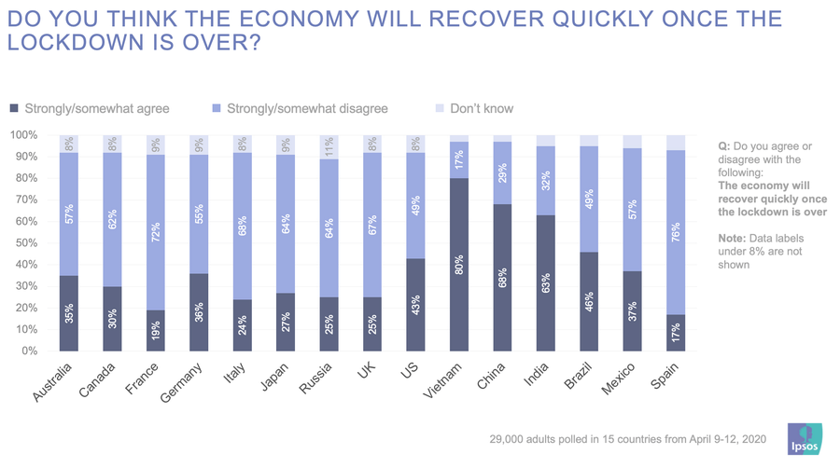People in Spain (76%), France (72%), Italy (68%), the United Kingdom (67%), Russia and Japan (64%), and Canada (62%) feel most strongly against a quick economic recovery in a survey of nearly 29,000 respondents conducted from April 9 to 12. Those in Vietnam (80%), China (68%) and India (63%) are most likely to say a quick recovery will take place.

At the same time, one of the countries most divided on this question is the world’s largest economy – the United States - with nearly half of those surveyed (49%) disagreeing on a quick recovery, while 43% think it will happen.

In terms of actions taken, majorities in India (56%), Brazil and Germany (54%) say all of the restrictions on travel and mandates for self-isolation will not stop the spread of COVID-19. That compares with majorities in China (63%), Australia (59%), Italy and Canada (58%), Spain (57%), the U.K., and Vietnam (54%) and France (51%) who think the restrictions do work.

Countries that have the seen the most significant change on this measure since mid-March are the ones where optimism has increased. Australia saw a drop of 17 percentage points in the number of those that agree the measures will not stop the spread of the pandemic, while the number of respondents in Japan fell by 13 points.

**References:**

**“‘A Brewing Storm’: Economic Impact of COVID-19 on Sri Lanka”,** [**Kithmina Hewage**](http://www.ips.lk/talkingeconomics/?author=54)

# “Public Opinion on the Covid-19 pandemic”, Ipsos experts

# Dataset Collecting Procedure

**import** selenium  
**from** selenium **import** webdriver  
**from** selenium.webdriver.common.keys **import** Keys  
**from** selenium.webdriver.common.by **import** By  
**from** selenium.webdriver.support.ui **import** WebDriverWait  
**from** selenium.webdriver.support **import** expected_conditions **as** EC  
**from** selenium.common.exceptions **import** TimeoutException, StaleElementReferenceException  
**from** bs4 **import** BeautifulSoup **as** bs  
**import** time  
  
  
**def** init_driver():  
 *# initiate the driver:* driver = webdriver.Chrome()  
  
 *# set a default wait time for the browser [5 seconds here]:* driver.wait = WebDriverWait(driver, 5)  
  
 **return** driver  
  
  
**def** close_driver(driver):  
 driver.close()  
  
 **return  
  
  
def** login_twitter(driver, username, password):  
 *# open the web page in the browser:* driver.get(**"https://twitter.com/login"**)  
  
 *# find the boxes for username and password* username_field = driver.find_element_by_class_name(**"js-username-field"**)  
 password_field = driver.find_element_by_class_name(**"js-password-field"**)  
  
 *# enter your username:* username_field.send_keys(username)  
 driver.implicitly_wait(1)  
  
 *# enter your password:* password_field.send_keys(password)  
 driver.implicitly_wait(1)  
  
 *# click the "Log In" button:* driver.find_element_by_class_name(**"EdgeButtom--medium"**).click()  
  
 **return  
  
  
class** wait_for_more_than_n_elements_to_be_present(object):  
 **def** __init__(self, locator, count):  
 self.locator = locator  
 self.count = count  
  
 **def** __call__(self, driver):  
 **try**:  
 elements = EC._find_elements(driver, self.locator)  
 **return** len(elements) > self.count  
 **except** StaleElementReferenceException:  
 **return False  
  
  
def** search_twitter(driver, query):  
 *# wait until the search box has loaded:* box = driver.wait.until(EC.presence_of_element_located((By.NAME, **"q"**)))  
  
 *# find the search box in the html:* driver.find_element_by_name(**"q"**).clear()  
  
 *# enter your search string in the search box:* box.send_keys(query)  
  
 *# submit the query (like hitting return):* box.submit()  
  
 *# initial wait for the search results to load* wait = WebDriverWait(driver, 10)  
  
 **try**:  
 *# wait until the first search result is found. Search results will be tweets, which are html list items and have the class='data-item-id':* wait.until(EC.visibility_of_element_located((By.CSS_SELECTOR, **"li[data-item-id]"**)))  
  
 *# scroll down to the last tweet until there are no more tweets:* **while True**:  
  
 *# extract all the tweets:* tweets = driver.find_elements_by_css_selector(**"li[data-item-id]"**)  
  
 *# find number of visible tweets:* number_of_tweets = len(tweets)  
  
 *# keep scrolling:* driver.execute_script(**"arguments[0].scrollIntoView();"**, tweets[-1])  
  
 **try**:  
 *# wait for more tweets to be visible:* wait.until(wait_for_more_than_n_elements_to_be_present(  
 (By.CSS_SELECTOR, **"li[data-item-id]"**), number_of_tweets))  
  
 **except** TimeoutException:  
 *# if no more are visible the "wait.until" call will timeout. Catch the exception and exit the while loop:* **break** *# extract the html for the whole lot:* page_source = driver.page_source  
  
 **except** TimeoutException:  
  
 *# if there are no search results then the "wait.until" call in the first "try" statement will never happen and it will time out. So we catch that exception and return no html.* page_source = **None  
  
 return** page_source  
  
  
**def** extract_tweets(page_source):  
 soup = bs(page_source, **'lxml'**)  
  
 tweets = []  
 **for** li **in** soup.find_all(**"li"**, class_=**'js-stream-item'**):  
  
 *# If our li doesn't have a tweet-id, we skip it as it's not going to be a tweet.* **if 'data-item-id' not in** li.attrs:  
 **continue  
  
 else**:  
 tweet = {  
 **'tweet_id'**: li[**'data-item-id'**],  
 **'text'**: **None**,  
 **'user_id'**: **None**,  
 **'user_screen_name'**: **None**,  
 **'user_name'**: **None**,  
 **'created_at'**: **None**,  
 **'retweets'**: 0,  
 **'likes'**: 0,  
 **'replies'**: 0  
 }  
  
 *# Tweet Text* text_p = li.find(**"p"**, class_=**"tweet-text"**)  
 **if** text_p **is not None**:  
 tweet[**'text'**] = text_p.get_text()  
  
 *# Tweet User ID, User Screen Name, User Name* user_details_div = li.find(**"div"**, class_=**"tweet"**)  
 **if** user_details_div **is not None**:  
 tweet[**'user_id'**] = user_details_div[**'data-user-id'**]  
 tweet[**'user_screen_name'**] = user_details_div[**'data-screen-name'**]  
 tweet[**'user_name'**] = user_details_div[**'data-name'**]  
  
 *# Tweet date* date_span = li.find(**"span"**, class_=**"_timestamp"**)  
 **if** date_span **is not None**:  
 tweet[**'created_at'**] = float(date_span[**'data-time-ms'**])  
  
 *# Tweet Retweets* retweet_span = li.select(**"span.ProfileTweet-action--retweet > span.ProfileTweet-actionCount"**)  
 **if** retweet_span **is not None and** len(retweet_span) > 0:  
 tweet[**'retweets'**] = int(retweet_span[0][**'data-tweet-stat-count'**])  
  
 *# Tweet Likes* like_span = li.select(**"span.ProfileTweet-action--favorite > span.ProfileTweet-actionCount"**)  
 **if** like_span **is not None and** len(like_span) > 0:  
 tweet[**'likes'**] = int(like_span[0][**'data-tweet-stat-count'**])  
  
 *# Tweet Replies* reply_span = li.select(**"span.ProfileTweet-action--reply > span.ProfileTweet-actionCount"**)  
 **if** reply_span **is not None and** len(reply_span) > 0:  
 tweet[**'replies'**] = int(reply_span[0][**'data-tweet-stat-count'**])  
  
 tweets.append(tweet)  
  
 **return** tweets  
  
  
driver = init_driver()  
  
*# log in to twitter (replace username/password with your own):*username = **"md.rukshan@gmail.com"**password = **"don19960927"**login_twitter(driver, username, password)  
  
*# search twitter:*query = **"covid19"**page_source = search_twitter(driver, query)  
  
*# extract info from the search results:*tweets = extract_tweets(page_source)  
 *# close the driver:*close_driver(driver)